ST. XAVIER’S COLLEGE

**Maitighar,Kathmandu**

**(Affiliated to Tribhuvan University)**



**Database Management System**

**Lab Assignment #6**

**Submitted By**

Arun Sanjel

B.Sc. CSIT

Year II/IV Semester

013BSCIT010

**Submitted To:**

Er. Sanjay Kumar Yadav

Lecturer,

Department of Computer Science

St. Xavier’s College

Maitighar, Kathmandu

**Submitted On:**

10th September , 2015

# Join

Join is a combination of a Cartesian product followed by a selection process. A join operation pairs two tuples from different relations, if and only if a given join condition is satisfied. SQL Join is used to fetch data from two or more tables, which is joined to appear as single set of data. SQL Join is used for combining column from two or more tables by using values common to both tables. Join Keyword is used in SQL queries for joining two or more tables. Minimum required condition for joining table, is (n-1) where n, is number of tables. A table can also join to itself known as, Self Join. Join are of two types:

* Theta Join
* Natural Join

# Theta join

Theta join combines tuples from different relations provided they satisfy the theta condition. The join condition is denoted by the symbol θ. In theta join we apply the condition on input relation(s) and then only those selected rows are used in the cross product to be merged and included in the output. It means that in normal cross product all the rows of one relation are mapped/merged with all the rows of second relation, but here only selected rows of a relation are made cross product with second relation.

# Natural Join

This is the most common and general form of join. If we simply say join, it means the natural join. It is same as equi­join but the difference is that in natural join, the common attribute appears only once. Now, it does not matter which common attribute should be part of the output relation as the values in both are same.

# Right Join

The RIGHT JOIN keyword returns all rows from the right table (table2), with the matching rows in the left table (table1). The result is NULL in the left side when there is no match.

Syntax

SELECT *column_name(s)*  
FROM *table1*  
RightJOIN *table2*  
ON *table1.column_name*=*table2.column_name*;

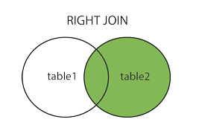

# Left Join

The LEFT JOIN keyword returns all rows from the left table (table1), with the matching rows in the right table (table2). The result is NULL in the right side when there is no match.

Syntax

SELECT *column_name(s)*  
FROM *table1*  
LEFT JOIN *table2*

ON *table1.column_name*=*table2.column_name*;

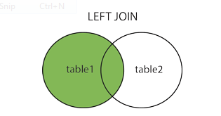

# Inner Join

The INNER JOIN keyword selects all rows from both tables as long as there is a match between the columns in both tables.

Syntax

SELECT *column_name(s)*  
FROM *table1*  
INNER JOIN *table2*

ON *table1.column_name*=*table2.column_name*;

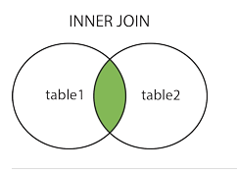

Rename Operation

Assignment Operation

Division Operation

Additional operation

Set Intersection Operation

Natural Join operation